The Enterprise has a 22-bit address space (A0 to A21) giving 4MB of addressable space!

The Z80 address space is divided into 16KB “Pages” (numbered 0-3) where A14 and A15 select four 8-bit “Segment” registers in “DAVE”.
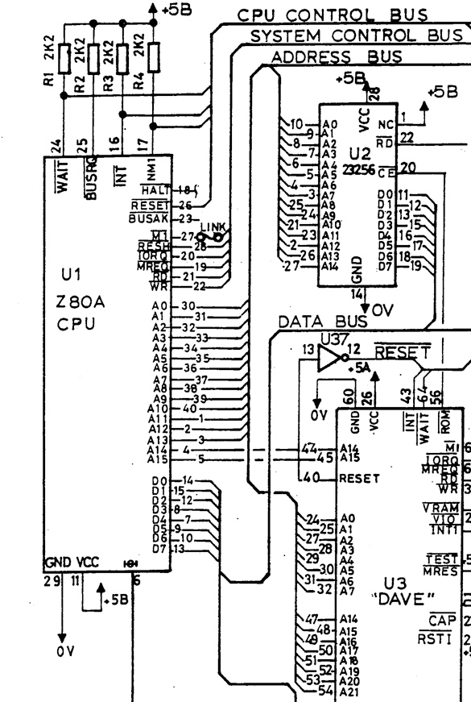

The Enterprise 4MB address space is divided into 256 16K “segments”. Each “Segment” has a number, 00h-FFh.
A0-A13 + 8-bits, from the “Segment” registers, generate the 22-bit address.

Certain “Segments” are predefined
Internal 32K ROM | 00h-01h
64K Cartridge Slot | 04h-07h
Internal 64K DRAM | FCh-FFh
2nd Internal 64K DRAM | F8h-FBh

There is Z80 I/O port associated with each “Segment” register in “DAVE” which allows the “Segment” number to be set for each “page”.
Page | Address | Port
0 | 0000h-3FFFh | B0h
1 | 4000h-7FFFh | B1h
2 | 8000h-BFFFh | B2h
3 | C000h-FFFFh | B3h

Any “Segment” can be mapped to any “Page” by writing the “Segment” number to the IO port for the respective “Page”.

Using 512KB SRAM (AS6C4008) with 19 address lines (A0 to A18), the “Segments” are as below;
Segment | A21 | A20 | A19 | A18 | A17 | A16 | A15 | A14 | Note
FF | 1 | 1 | 1 | 1 | 1 | 1 | 1 | 1 | Internal DRAM
FE | 1 | 1 | 1 | 1 | 1 | 1 | 1 | 0 | Internal DRAM
FD | 1 | 1 | 1 | 1 | 1 | 1 | 0 | 1 | Internal DRAM
FC | 1 | 1 | 1 | 1 | 1 | 1 | 0 | 0 | Internal DRAM
FB | 1 | 1 | 1 | 1 | 1 | 0 | 1 | 1 | 512K SRAM
FA | 1 | 1 | 1 | 1 | 1 | 0 | 1 | 0 | 512K SRAM
F9 | 1 | 1 | 1 | 1 | 1 | 0 | 0 | 1 | 512K SRAM
F8 | 1 | 1 | 1 | 1 | 1 | 0 | 0 | 0 | 512K SRAM
F7 | 1 | 1 | 1 | 1 | 0 | 1 | 1 | 1 | 512K SRAM
F6 | 1 | 1 | 1 | 1 | 0 | 1 | 1 | 0 | 512K SRAM
F5 | 1 | 1 | 1 | 1 | 0 | 1 | 0 | 1 | 512K SRAM
F4 | 1 | 1 | 1 | 1 | 0 | 1 | 0 | 0 | 512K SRAM
F3 | 1 | 1 | 1 | 1 | 0 | 0 | 1 | 1 | 512K SRAM
F2 | 1 | 1 | 1 | 1 | 0 | 0 | 1 | 0 | 512K SRAM
F1 | 1 | 1 | 1 | 1 | 0 | 0 | 0 | 1 | 512K SRAM
F0 | 1 | 1 | 1 | 1 | 0 | 0 | 0 | 0 | 512K SRAM
EF | 1 | 1 | 1 | 0 | 1 | 1 | 1 | 1 | 512K SRAM
EE | 1 | 1 | 1 | 0 | 1 | 1 | 1 | 0 | 512K SRAM
ED | 1 | 1 | 1 | 0 | 1 | 1 | 0 | 1 | 512K SRAM
EC | 1 | 1 | 1 | 0 | 1 | 1 | 0 | 0 | 512K SRAM
EB | 1 | 1 | 1 | 0 | 1 | 0 | 1 | 1 | 512K SRAM
EA | 1 | 1 | 1 | 0 | 1 | 0 | 1 | 0 | 512K SRAM
E9 | 1 | 1 | 1 | 0 | 1 | 0 | 0 | 1 | 512K SRAM
E8 | 1 | 1 | 1 | 0 | 1 | 0 | 0 | 0 | 512K SRAM
E7 | 1 | 1 | 1 | 0 | 0 | 1 | 1 | 1 | 512K SRAM
E6 | 1 | 1 | 1 | 0 | 0 | 1 | 1 | 0 | 512K SRAM
E5 | 1 | 1 | 1 | 0 | 0 | 1 | 0 | 1 | 512K SRAM
E4 | 1 | 1 | 1 | 0 | 0 | 1 | 0 | 0 | 512K SRAM
E3 | 1 | 1 | 1 | 0 | 0 | 0 | 1 | 1 | 512K SRAM
E2 | 1 | 1 | 1 | 0 | 0 | 0 | 1 | 0 | 512K SRAM
E1 | 1 | 1 | 1 | 0 | 0 | 0 | 0 | 1 | 512K SRAM
E0 | 1 | 1 | 1 | 0 | 0 | 0 | 0 | 0 | 512K SRAM
DF | 1 | 1 | 0 | 1 | 1 | 1 | 1 | 1 | 512K SRAM
DE | 1 | 1 | 0 | 1 | 1 | 1 | 1 | 0 | 512K SRAM
DD | 1 | 1 | 0 | 1 | 1 | 1 | 0 | 1 | 512K SRAM
DC | 1 | 1 | 0 | 1 | 1 | 1 | 0 | 0 | 512K SRAM
DB | 1 | 1 | 0 | 1 | 1 | 0 | 1 | 1 | No SRAM

Note DF-DC maps over the Internal DRAM “Segments” but with A19 low.

Decoded Address Line signals to drive CE on the 512KB SRAM are as follows;
(A21 & A20 & A19 & A18 & A17 & !A16)
# (A21 & A20 & A19 & A18 & !A17)
# (A21 & A20 & A19 & !A18)
# (A21 & A20 & !A19 & A18 & A17 & A16)

Additionally, the Control Lines for a Memory Request and excluding Refresh cycles are required.
!MREQ & REFSH
ChatGPT reduced this but it is easier to follow the above.
!CE=A21 & A20 & !MREQ & RFSH & (A19 & !A18 # A19 & /A17 # A19 & /A16 # /A19 &A18 & A17 &A16)

